**The following describes the levels of approval required for all plans and amendments.**

1. For PMEL, Collen Marquist is first to review the plan. For AFSC and NWFSC, Burlyn Birkemeier is first to review the plan. Initials are required from one College Health and Safety Committee member (Birkemeier and Marquist) before the PI can sign.
2. The supervisor of the employee submitting the plan adds their revisions.
3. When all revisions have been addressed, the project PI signs the plan or amendment and emails the Google link to John Horne ([jhorne@uw.edu](mailto:jhorne@uw.edu)) and Collen Marquist ([marquist@uw.edu](mailto:marquist@uw.edu)).
4. John Horne will point out necessary comments or revisions. Once they have all been addressed, John will download the plan as a PDF, sign it, and email the final version to the PI, field scientist, and Collen Marquist.

| **CICOES** | **Cooperative Institute for Climate, Ocean & Ecosystem Studies** | | |
| --- | --- | --- | --- |
| **Plan Created for** | College of the Environment, CICOES, NOAA PMEL EcoFOCI and ‘Omics and NOAA AFSC Marine Mammal Laboratory | **Date of revision:** | 03/03/2023 |
| **CICOES PI/Supervisor** | Calvin Mordy - [calvin.w.mordy@noaa.gov](mailto:calvin.w.mordy@noaa.gov) | **Budget Number:** EcoFOCI (budget #), Omics (Task II Genomics 62-3574), MML (Task II Acoustics 62-3457) | |
| **Field Team Leader/ Chief Scientist and Names of Participants** | **Chief Scientist**: Shaun Bell - [shaun.bell@noaa.gov](mailto:shaun.bell@noaa.gov) (405-326-4283)  David Strausz - [david.strausz@noaa.gov](mailto:david.strausz@noaa.gov) (509-830-7445) - EcoFOCI  Peter Proctor - [Peter.Proctor@noaa.gov](mailto:Peter.Proctor@noaa.gov) (206 604 8638) - EcoFOCI  Brynn Kimber - [brynn.kimber@noaa.gov](mailto:brynn.kimber@noaa.gov) (360-739-9554) - MML  Shannon Brown - [shannon.brown@noaa.gov](mailto:shannon.brown@noaa.gov) (847-445-2292) - OMICS | | |
| **Activity Description** | The purpose of the spring morning cruise is to turn around various FOCI and MML moorings located in the Bering Sea and perform CTD/Bongo surveys at long-term EcoFOCI moored sites. | | |
| **Field Site Location(s)** | Field sites are located in the Gulf of Alaska and Bering Sea (see Appendix 1). The vessel will depart from Kodiak, AK and return to Dutch Harbor, AK. | | |
| **Date(s) of Fieldwork** | 21 April 2023 to 7 May 2023 | | |

**Preliminary review conducted by: __________ Initials of Health and Safety Representative: _________**

| **Approved by:** | *Dean or School/department/program chair or director* | *MM/DD/YY* |
| --- | --- | --- |

**Adherence to University policy and a professional code of conduct by all members of a project field team while participating in University-sponsored fieldwork is required.**

# 

# 

# Signature of PI/Supervisor:

I approve this safety plan and acknowledge that it has been prepared for fieldwork under my supervision.

| **Name** | **Signature** | **Date** | **Phone Number** |
| --- | --- | --- | --- |
| Calvin Mordy - [calvin.w.mordy@noaa.gov](mailto:calvin.w.mordy@noaa.gov) |  |  |  |

**Field Team/Participant Roster - Training Documentation1**

**I understand that this Project Health and Safety Plan is intended to document hazard assessments, communication plans, emergency procedures, and training requirements for the proposed fieldwork. This plan also identifies hazards, as well as precautions and actions to be taken to address and mitigate those hazards, to significantly mitigate the risk of COVID-19 exposure and transmission, but is not a substitute for self-isolation for individuals who may have concerns about their health or that of others. I verify that I have read this Fieldwork Health and Safety Plan, understand its contents, am voluntarily participating in the fieldwork, and agree to comply with its requirements.**

| **Name/Email/Cell Phone #** | **Signature** | **Date** | **First Aid Training Completed\*** |
| --- | --- | --- | --- |
| David Strausz [david.strausz@noaa.gov](mailto:david.strausz@noaa.gov)  (509-830-7445) |  |  | Adult, Child and Baby First Aid/CPR/AED Online - Completed 12/2021 |
| Peter Proctor [Peter.Proctor@noaa.gov](mailto:Peter.Proctor@noaa.gov)  (206 604 8638) | [Peter d' Proctor](mailto:peterdurphee@gmail.com) | 3/09/2023 | Adult, Child and Baby First Aid/CPR/AED Online - Completed 07/20/2022 |
| Brynn Kimber [brynn.kimber@noaa.gov](mailto:brynn.kimber@noaa.gov)  (360-739-9554) |  | 3/6/2023 | Wilderness survival, 3/21  Adult First Aid 1/2/2022 |
| Shannon Brown [shannon.brown@noaa.gov](mailto:shannon.brown@noaa.gov) (847-445-2292) |  | 3/6/2023 | Adult First Aid/CPR/AED Online Only- Completed 6/2021 |

**1All research field teams must include at least one individual with valid first aid certification.**

| Site Information | |
| --- | --- |
| **Location(s)** | 4/18/2023 - Arrive in Kodiak, AK  4/19-20/2023 - In-Port COVID Testing; Load Ship  4/21/2023 - Depart from Kodiak to Bering Sea  4/22/2023-5/6/2023 - Conduct mooring, CTD, and bongo net operations  5/7/2023 - Arrive in Dutch Harbor, AK  5/8/2023 - Return to Seattle |
| **Site Information** | Work will be conducted on board the NOAA ship, Oscar Dyson. A majority of the work will be outdoors on the back deck and on the side deck for the CTD and bongo nets. The CTD will be run from the electronics lab, and all samples will be processed in the chem or wet lab.  Weather conditions in the Bering can be unpredictable and cold. Safety meetings will be held before each mooring operation to review safety issues and discuss weather options, if applicable. Steel toe boots are required on deck along with mustang float coats and hardhats. Waterproof insulated gloves are provided for working on deck as it is anticipated that working conditions will occur during freezing temperature. |
| **Travel to Site** | All CICOES participants will travel to Kodiak, AK and from Dutch Harbor, AK via commercial airline. In both localities, rental cars will be used to transit between the airport, hotel, stores, and dock. In accordance with Marine Operation Guidelines, all personnel are required to take a COVID test within 24 hours of departure. |
| **Ownership** | NOAA Ship *Oscar Dyson*  Marine Operations Center-Pacific  2002 SE Marine Science Dr.  Newport, OR 97365  [Noaa.Ship.Oscar.Dyson@noaa.gov](mailto:Noaa.Ship.Oscar.Dyson@noaa.gov) |
| **Access** | *Are there any particular restrictions or challenges to accessing site? Are collecting or camping permits required? Note any alternate routes or suggested parking areas; gate access codes, etc.* *Make special note if isolated or remote:*  No  Is/are your site(s) open to the public, or do you have written confirmation of your ability to access the site?   | ☐ | Open to the public | ⌧ | Written confirmation of access | ☐ | N/A | | --- | --- | --- | --- | --- | --- | |
| **Security** | Personal safety risks and conduct expectations during both work and free time should be considered and discussed in advance (e.g., alcohol or drug use, leaving the group, situational awareness, sexual harassment, and local crime/security concerns). Review expectations and set the tone for a safe, successful trip. In addition, describe any current travel alerts or restrictions. Note intended mitigation measures; discuss with the field team prior to the trip.   | ⌧ | There are currently no relevant travel measures or restrictions for the location of this work | | --- | --- | | ⌧ | All participants are informed and aware of conduct expectations, which will be discussed prior to the start of work. | | ⌧ | All participants are aware of the personal safety risks involved in this project. They have received proper training and have sufficient experience to complete this type of work. | | ⌧ | All relevant work and conduct protocols, manuals, or information has been distributed, understood, and will be discussed prior to the trip. |   *Please list any other security measures, if applicable*:  Boarding procedures during the loading of the Oscar Dyson include checking in with the watch on the bridge and showing proper ID. The OSI facility is a marine loading facility an as such TWIC or CAC cards are required to enter the property. There are no current travel alerts or restrictions for either ports. |
| **Team Safety** | All members of the UW community have the right to a non-harassing (both sexual and non-sexual in nature) and non-discriminatory environment both on campus and in fieldwork situations. Individuals are encouraged to bring up safety and well-being concerns for themselves or others with the following individuals:  **Field Team**   * Field Team Leader/Chief Scientist: Shaun Bell * Another senior person (e.g., Co-PI, ship captain, bosun): David Strausz * Other members of the science team: Brynn Kimber * On-site anonymous reporting mechanism: *Describe process, if applicable*   Campus resources can be found in the Reference Information section. |
| **No Go Criteria** | Conditions under which approach to - or activities at - the site will be stopped or canceled.     | ☐ | A confirmed or suspected case of COVID-19 by any personnel involved would stop or cancel operations. | | --- | --- | | ⌧ | Each participant understands that they have the ability to end their participation if they are concerned with any aspect of field operations, feel uncomfortable, or if they are unable to perform their duties safely for any reason. | | ⌧ | Work will not be conducted in unsafe weather conditions. If weather (high winds, low visibility, heavy rains, snow, etc.) will impact the safety of the participants, work will be delayed until it is safe to proceed. | | ⌧ | The decision to conduct work in safe conditions will be discussed by all team members, and ultimately is the responsibility of Shaun Bell to decide if it is safe to proceed. |   *List any other applicable conditions or situations that may stop or cancel field operations:*  All mooring operations will be preceded with a safety meeting to ascertain safe working conditions. Work on the back deck of the ship will be weather dependent. If waves exceed ~10 feet then mooring operations will be delayed until conditions improve. CTD and Bongo stations will be discussed between the bridge and the chief scientist when weather conditions deteriorate to a questionable level.  All participants will be required to test for COVID before departure. A positive test or known contact with a person known to have COVID will remove that person from the cruise. During the cruise, if a person is suspected of having COVID symptoms, the person will be isolated and the ship will return immediately to the nearest port. |
| **Environmental**  **Hazards** | *Describe any dangerous wildlife, insects, endemic diseases, poisonous plants, etc. that participants may encounter. Note intended mitigation measures; discuss prior to trip.*  None |
| **Expected Weather** | The Captain will take into account the weather conditions before departing Dutch Harbor. During the spring mooring cruise, it is expected that the Dyson will encounter snow and or heavy rain. Appropriate working attire will be furnished before the cruise to each participant (no sharing) and they will be reminded of the need to stay dry and to ‘layer up’. It is also expected that at some point the ship will be required to ‘hide’ from bad weather. The Captain in consultation with the chief scientist will make the decision when and where to seek refuge. |
| **Drinking Water Availability** | | ⌧ | Plumbed water available | ☐ | Water cooler with ice provided | ☐ | Bottled water provided | | --- | --- | --- | --- | --- | --- | | ☐ | Natural source and treatment methods (e.g. filtration, boiling, chemical disinfection): | | | | | |
| **Access to Shade/Shelter** | If forecast temperatures exceed 80°F, shade must be provided by natural or artificial means for rest breaks. What will be available to the field team members?   | ⌧ | Building structures | ☐ | Trees | ⌧ | Temporary Canopy/Tarp | ☐ | Vehicle with A/C | | --- | --- | --- | --- | --- | --- | --- | --- |  | ⌧ | Other: temperature will not reach these levels in Alaska | | --- | --- | |
| **High Heat Procedures** | Required when temperatures are expected to exceed 95° F: If possible, limit strenuous tasks to morning or late afternoon hours. Rest breaks in shade must be provided at least 10 minutes every 2 hours (or more if needed). Effective means of communication, observation and monitoring for signs of heat illness are required at all times. Pre-work safety discussion required.   | ☐ | Direct supervision | ☐ | Buddy system | ☐ | Reliable cell or radio contact | | --- | --- | --- | --- | --- | --- |  | ⌧ | Other: temperature will not reach these levels in Alaska | | --- | --- | |
| **Cold Weather Procedures** | Required when temperatures drop below normal and wind speed increases, allowing heat to leave a body more rapidly: If possible, schedule heavy work during the warmer part of the day. Provide frequent breaks in warm areas. Acclimatize new workers and those returning after time away from work. Effective means of communication, observation and monitoring for signs of cold stress are required at all times. Pre-work safety discussion required.   | ⌧ | Direct supervision | ⌧ | Buddy system | ⌧ | Reliable cell or radio contact | | --- | --- | --- | --- | --- | --- | | ☐ | Other:___________________________________________________________ | | | | | |

| Activities, Equipment, and Supplies – Describe hazards and risks | |
| --- | --- |
| **Research Activities** | *Briefly describe the goal of your field operations, e.g. collection of samples, observation of animals/environment, etc.…*  This project is intended to recover five (5) PMEL subsurface moorings and one (1) PMEL surface mooring and to deploy eight (8) PMEL subsurface moorings and four (4) PMEL surface moorings at the Bering Sea sites of M2, M4, KU1, KU2, KU3, KU4 (recovery only), & UPP3 which is a site in the south of Unimak Pass. In addition, four (4) marine mammal moorings are to be recovered and four (4) marine mammal moorings will be deployed. A hydrographic/biological survey consisting of Conductivity/Temperature/Depth (CTD) casts, 20/60 cm bongo tows and California Vertical Egg Tows (CalVETs) in the Unimak Pass area, along the 70-meter isobath in the Bering Sea as far north as the sea ice permits, and in boxes around the 4 mooring sites at M2, M4, M5, & M8. Additionally, we will deploy up to two (2) popup buoys, up to four (4) satellite tracked drifters, up to two (2) gliders and up to 48 Sonobuoys. |
| **Field**  **Transportation** | *What vehicles will be used during field operations? e.g. chartered boat, paddle craft, car, ATV, truck with trailer, snowmobile, chartered plane or helicopter, etc.*  NOAA Ship *Oscar Dyson*  *Who is authorized to operate/use each vehicle?*  NOAA Dyson Caption and NOAA Corps Officers |
| **Research Tools and Supplies** | *Briefly describe tools or equipment that will be used to access the research site or during research activities. Indicate specific training required before use, e.g. sharps (knives, razors, needles), hand tools, heavy machinery, specialty equipment, firearms; lasers, portable welding/soldering devices; other hazardous equipment or tools. If applicable, describe any supplies necessary to support functions (e.g. food, water, toilet paper) and indicate what will be brought from the point of departure and what will be acquired in the field.*  CICOES participants, alongside other crew, will assist with the preparation, deployment, and recovery of moorings. Shipboard operations include the use of the cranes and  winches to offload and load gear will be handled by the trained crew of the Oscar Dyson.  The Oscar Dyson’s CTD rosette will be used to collect water samples. The ship’s crew are responsible for the equipment and deployment; the science party will discuss all procedures before starting an operation and will follow the instructions of the ship’s crew. All science personnel will have their own PPE including a hard hat, face mask, gloves, steel-toed boots, float coat, and rain pants. The ship provides basic tools for operations, and the CICOES traveler will supply specialty tools and supplies as needed to complete mooring and loading operations. |
| **Other Research Hazards** | *Describe other potential research-associated hazards, e.g., handling or shipping hazardous materials (chemical, biological, radiation, and explosives), drone use, handling animals, climbing or working at heights, rigging; entering confined spaces.*  Deck work during the cruise and mooring operations will involve heavy lifting and rigging. Steel toed boots are required on deck during all craning and lifting operations. Hard hats are required for all deck work as are properly outfitted float coats and proper cold weather attire.  Certain samples obtained during the cruise will be preserved with hazardous chemicals. Please  see the attached cruise instructions (Appendix 5) for handling and spill cleanup instructions. |
| **Personal Protective Equipment** | Required: Steel toed boots, hardhats, float coats, masks (surgical or KN95), disinfecting wipes  Recommended: Cold weather gear  All scientists will be required to wear hard hats and float coats or vests while working on deck. These will be provided by the scientific party. In addition, whenever working on deck while loads are being lifted, steel toed boots are required to be worn. These are expected to be brought to the ship by each scientist as provided by their respective organizational group. |
| **First Aid Supplies** | | ⌧ | An emergency first aid kit will be available to the entire field team at all times | | --- | --- |   Location and description of group medical/first aid kit(s): *Who is carrying it, where is it stored. Brief description of contents. Please include whether or not any participants will be carrying an EpiPen for the emergency treatment of anaphylaxis.*  While aboard the Oscar Dyson, a complete medical room is available which contains most supplies expected to be found in an emergency room at a hospital. This includes a defibrillator, suture equipment, and medical supplies and prescriptions needed. If a member field team requires urgent medical attention, emergency services will be called immediately. There are numerous first aid kits located around the interior and exterior of the vessel. All participants have been recommended to obtain emergency evac coverage.  If a member field team requires urgent medical attention, who is the first point-of-contact in the field? e.g., ship captain, chief scientist, helicopter owner dispatch, etc.  Ship Captain + Chief Scientist |

| Animal Research | |
| --- | --- |
| **Animal Research** | | N/A | Does your fieldwork require a Collection, Import, Transfer or other permit? If yes, attach a copy of all permits to this Plan. | | --- | --- | | N/A | If research will be done with animals at a foreign site, identify whether institutional reviews will be required and whether there will be additional costs for those reviews. | |

| Participant Information | |
| --- | --- |
| **Field Team/ Participants** | Field Team Leader/Chief Scientist:Shaun Bell - [shaun.bell@noaa.gov](mailto:shaun.bell@noaa.gov) (405-326-4283)  Secondary Field Team Leader:David Strausz - [david.strausz@noaa.gov](mailto:david.strausz@noaa.gov) (509-830-7445)   | ⌧ | Field Team/Participant list is attached and includes training documentation | | --- | --- | | ⌧ | The field team is reduced to the minimum number necessary to safely carry out the work | |
| **Physical Demands** | *List any physical demands required for this trip, e.g. diving, swimming, hiking, climbing, high altitudes, respirators, heights, confined or restricted spaces, etc.*  Working on the dock and the back deck of a ship with heavy gear. This work will occur when loading the ship in Kodiak and while conducting several mooring operations. Gear will be unloaded in Dutch Harbor, AK. All CICOES participants are aware of these demands and are prepared to work in this environment. |
| **Mental Demands** | *List any unique mental demands required for this trip, e.g. long travel days, high stress environments, different cultural norms, etc.*  Mental demands are incurred while working in poor weather conditions for long hours with heavy equipment. All CICOES participants are aware of these demands. |
| **Lone Worker** | Is anyone working alone?   | ☐ | Yes | ⌧ | No | | --- | --- | --- | --- |   *If yes, describe a communications plan with strict check-in procedures (daily at a minimum) and actions to be taken in the event of a failure to establish contact when expected. If cell coverage is unreliable, a satellite communication device and/or personal locator beacon must be carried.* |
| **Training** | [UW policy (APS 10.5)](http://www.washington.edu/admin/rules/policies/APS/10.05.html) requires that all academic and/or research field teams must include at least one person with valid first aid certification. The level of first aid training required will depend on the type of activity the team is pursuing; the location; and the availability, response time, and means of communication by and with emergency response units. The EH&S Training office (206-543-7201, [ehstrain@uw.edu](mailto:ehstrain@uw.edu)) can advise on the first aid training and certification requirements on a case-by-case basis.  *List team members trained in first aid, type of training received (e.g., First Aid, CPR, Wilderness First Aid), and date of certification. Copies of first aid certification should be attached in the appendix* (Appendix 4).  Training Information for Each Participant Listed Here  Shannon Brown - Adult First Aid/CPR/AED Online Only  David Strausz - Adult, Child and Baby First Aid/CPR/AED Online  Brynn Kimber -Wilderness survival, Adult First Aid  Peter Proctor - Adult First Aid/CPR/AED Online Only  *List additional training necessary for this project, including but not limited to Aircraft Egress & Ditching, HEEDS/EUBA, STCW Training, UAS, forklift, and Defensive Driving:* |
| **Immunizations or Required Medical Evaluation** | For travel-related immunizations or medical advice, contact [UW Travel Medicine](https://wellbeing.uw.edu/medical/travel-health/) 6-8 weeks in advance of departure.  *List required immunizations/prophylaxis or required medical evaluation such as TB test, if applicable.*  As of October 2021, all University of Washington staff are required to be fully vaccinated against COVID-19. All Oscar Dyson crew traveling are required to be vaccinated and have provided proof to NOAA. No additional immunizations are required. |
| **Side Trips** | Will this trip include personal time?   | ⌧ | No side trips will occur | | --- | --- | | ☐ | Yes (please provide location and dates): | |

| Emergency Services and Contact Information | | | |
| --- | --- | --- | --- |
| **Local Contact at**  **Research Location** | Shaun Bell  **Chief Scientist**  [shaun.bell@noaa.gov](mailto:shaun.bell@noaa.gov) (405-326-4283) | **University Contact**  Collen Marquist  [marquist@uw.edu](mailto:marquist@uw.edu)  206-330-6740 (cell) | Phyllis Stabeno  **EcoFoci Project Manager**  [phyllis.stabeno@noaa.gov](mailto:phyllis.stabeno@noaa.gov)  206-526-6453  Matt Galaska  **NOAA Omics PI**  [matt.galaska@noaa.gov](mailto:matt.galaska@noaa.gov)  206-526-6047  Catherine Berchok  **Acoustics Team Leader**  [catherine.berchok@noaa.gov](mailto:catherine.berchok@noaa.gov)  206-664-1448  **Participants are expected to check in with their PI upon arrival and after they have returned.** |
| **Lodging Location** | **In Kodiak:** Best Western Kodiak Inn, 236 E Rezanof Dr, Kodiak, AK 99615 Phone: (907) 486-5712  **In Dutch Harbor**  Grand Aleutian Hotel, 498 Salmo Way, Unalaska, AK 99692  Phone: 907-581-3844 | | |
| **Local Emergency Number** | 911 | | |
| **Nearest Emergency Department** | *Evacuation plan and transportation options to the nearest Emergency Department; include estimated transport time, contact information and driving directions from the site to the nearest provider of emergency medical care. Attach map with specific directions.*  Scientists will be embarking in Kodiak, AK, and the nearest hospital is Providence Kodiak Island Medical Center, which is 5 min from port (Appendix 2). They will all disembark in Dutch Harbor, AK where Iliuliuk Family and Health Services, Inc (907-581-1202; [www.ifhs.org](http://www.ifhs.org)) is 4 min from port and 5 min from the hotel (Appendix 2). If a medical emergency occurs while onboard, in urgent cases, the crew will be transported back to port, and emergency services will provide transportation. The ship can communicate with the US Coast Guard in an emergency. | | |
| **Cell Phone Coverage** | **Primary Number:** Shannon Brown (847-445-2292)  **Coverage:** Spotty  **Nearest location with reliable coverage:** liable communication is obtained using WhatsApp when near a wireless hotspot | | |
| **Satellite phone/other device** | **Device carried?**   | ⌧ | Yes | ☐ | No | | --- | --- | --- | --- |   **Type/number (required):** (541-867-8911)  **Location/access:** Oscar Dyson has a satellite phone of the bridge | | |
| **Participant Emergency Contact Information** | While the University cannot require field participants to provide current emergency contact information and proof of medical insurance   | ⌧ | Field team members are encouraged to maintain current emergency contact information in Workday for use in case of an emergency. Checkbox confirms information is current. | | --- | --- | | | |
| **Primary CICOES Contacts** | **Executive Director: John Horne;** [**jhorne@uw.edu**](mailto:jhorne@uw.edu)**; 206-221-6890**  **Assistant Director: Fred Averick;** [**faverick@uw.edu**](mailto:faverick@uw.edu)**; 206-616-6763**  **Safety and Health Manager: Collen Marquist;** [**marquist@uw.edu**](mailto:marquist@uw.edu)**; 206-330-6740 (cell)**  These individuals should have access to a copy of your final project Health and Safety Plan. | | |

| Reference Information | |
| --- | --- |
| **Report Injuries and Accidents** | Report any work-related injury or illness to your supervisor as soon as possible. After reporting the incident to your supervisor, submit a report of the incident within 24 hours to EH&S via the UW’s [Online Accident Reporting System (OARS)](https://oars.ehs.washington.edu/).  **Call EH&S immediately at 206-543-7262 if the incident involves any of the following:**   * In-patient hospitalization * Recombinant/synthetic DNA exposure or spill * Fatality   EH&S must immediately report any employee in-patient hospitalization or fatality to Washington State Department of Labor & Industries (L&I). **Do not move any equipment involved in the incident until EH&S receives clearance from L&I.**  **Outside EH&S business hours (8:00 a.m. to 5:00 p.m., Monday to Friday), call the UW Police Department (UWPD) at 206-685-UWPD (8973).** UWPD will notify an EH&S on-call staff member.  **EH&S Contact Information:** 206-543-7262, [ehsdept@uw.edu](mailto:ehsdept@uw.edu) |
| **Mental Health** | Employees: [CareLink](https://hr.uw.edu/benefits/uw-carelink/) (24 hours a day, 7 days a week, 866-598-3978)  Students   * Bothell: [Counseling Center](https://www.uwb.edu/studentaffairs/counseling) (425-352-3183) * Seattle: [Counseling Center](https://wellbeing.uw.edu/topic/mental-health/) (206-543-1240) and [Hall Health Mental Health](https://wellbeing.uw.edu/topic/mental-health/) (206-543-5030) * Tacoma: [Counseling & Psychological Services](https://www.tacoma.uw.edu/studentcounseling) ([uwtcaps@uw.edu](mailto:uwtcaps@uw.edu)) * While Abroad – The UW Student Abroad Insurance has mental health coverage. Students can arrange to see a mental health provider in-person locally or remotely.   National Suicide Prevention Lifeline (24 hours a day, 7 days a week, 800-273-8255) |
| **Medevac Alaska** | The following companies serve evacuation in Alaska:   * Medevac Alaska; 877-985-5022; <https://www.medevacalaska.com/> * Lifemed Alaska; 855-907-5433; <https://www.lifemedalaska.com/> * AirMedCare Network; 855-408-3787; [www.airmed.com](http://www.airmed.com) * Airlift NW; 800-426-2430; <https://www.uwmedicine.org/airliftnw> |
| **Report Harassment** | **UW Resources and Reporting**  *(NOTE: UW Advocates and Offices may be contacted regardless of the institutional affiliation(s) of the individuals involved).*  Confidential Advocates for support, information and assistance   * Faculty/Postdocs/Staff - Victim Advocate: UWPDAdvocate@uw.edu, 206-543-9337 * Students * Bothell: Violence Prevention and Advocacy Program Manager, uwbvae@uw.edu, 425-352-3851 * Seattle: Livewell Student Advocate: hwadvoc@uw.edu, 206-685-4357 * Tacoma: Assistant Director for Student Advocacy and Support, uwtsva@uw.edu, 253-692-5934   Other University Resources   * [SafeCampus](https://www.washington.edu/safecampus/): 24 hours a day, 7 days a week, 206-685-7233 * UW Global Emergency Line for international assistance: 206-632-0153 (Emergency) or 206-616-7927 (Non-Emergency) * Office of Ombud (office hours): ombuds@uw.edu, 206-543-6028 |
| **Volunteers** | [UW Risk Services describes volunteers](https://risk.uw.edu/advice/consulting/volunteers) and the process for ensuring their work is authorized in writing and in advance so that they have access to both UW liability coverage and limited workers’ compensation coverage (medical payments only) for their approved duties.  If your project involves volunteers, create a volunteer service agreement for each volunteer that documents the person’s name, a description of the duties they’ll be performing, and the dates and hours of work. Volunteer service should not be engaged in by individuals if is it is not permitted by their visa status and/or immigration law rules.  N/A |
| **Minors** | [University Policy (APS 10.13)](https://www.washington.edu/admin/rules/policies/APS/10.13.html) requires all UW and third party led youth programs to register with the UW Youth Program Registration System (YPRS). If your field project is employing volunteers or is otherwise engaging individuals under age 18:   * register project in the [YPRS](https://apps.ideal-logic.com/uwypds); * confirm completion of both background checks and the two required trainings for all authorized personnel **before** your program start date   It is recommended that you begin the YPRS registration process at least 1 month prior to the program start date. Contact the [Youth at UW Program](https://www.washington.edu/youth/) if you have questions.  N/A |
| **Insurance** | **Equipment Insurance**  University property and equipment is not automatically insured. [UW Equipment Insurance](https://risk.uw.edu/insure/EIS) is a campus-wide online program administered by Risk Services which provides optional, low cost coverage to University departments for owned, leased or borrowed equipment used for UW work.  N/A  **Travel Insurance**  University employees, including student employees, are covered by Washington State L&I and other US states for work-related injuries. However, for remote transport, purchase annual medical evacuation insurance.  N/A |

| Appendices |
| --- |

**Appendix A. COVID-19 Supplemental Information and Symptom Attestation**

1. **Map of EcoFoci Fall Mooring Cruise Sampling Plan**
2. **Map with specific directions to closest Emergency Department in Dutch Harbor, AK and Kodiak, AK**
3. **Required PPE provided by project grant and disinfection supplies**
4. **First Aid Training Certification(s)**

**Appendix A. COVID-19 Supplemental Information and Symptom Attestation**

| COVID-19 Supplemental Information | |
| --- | --- |
| **COVID-19 Virus Testing and Quarantine**  **Follow the most conservative**  **protocol.** | UW is following CDC guidelines that do not require quarantine and testing for domestic or international travel. When research vessels and partner institution scientists adhere to more conservative COVID guidelines, CICOES staff will follow the same protocols.  Members of the field team who exhibit any symptoms of illness within 72 hours prior to departure MUST stay home. Select which of the following apply to this field effort:   | ☐ | Employees will wear masks at all times when indoors, or when outdoors and 6 ft. distance cannot be maintained. | | --- | --- | | ⌧ | CICOES employees have verified their COVID-19 vaccination status with the University of Washington, and are up to date on their boosters. Employees will not participate in field activities or travel if they show any signs or symptoms of illness. | | ⌧ | Employees will follow [EH&S Cleaning and Disinfection Resources](https://www.ehs.washington.edu/system/files/resources/cleaning-disinfection-protocols-covid-19.pdf) and CDC protocols on cleaning and disinfecting. In alignment with public health recommendations, field teams will undertake [enhanced cleaning and disinfection procedures](https://www.ehs.washington.edu/system/files/resources/cleaning-disinfection-protocols-covid-19.pdf) by increasing the frequency of cleaning and disinfecting, focusing on high-touch surfaces in common areas, restrooms, etc. They will identify all high touch surfaces in communal spaces and disinfect them before and after use, and daily at a minimum. | | ☐ | Employees will travel in vehicles with only persons within their field team and will not carry any other passengers at any time. | | ⌧ | Employees will use delivery or carry-out options at grocery stores or restaurants whenever possible, and will wash or sanitize their hands before and after meals. |   Describe any additional quarantine or testing protocols which will be observed by the CICOES employee(s) or field team:  The Oscar Dyson no longer has any official COVID specific policies but the following measures will be taken:   1. All team members will take a rapid COVID test before traveling to Alaska. 2. All team members shall wear a mask during transportation to the duty station. 3. All team members will take an additional COVID test before boarding the ship. |
| **Reporting Cases of COVID-19** | If a member of the field team shows any symptoms of COVID-19 infection, they should do the following:   1. Isolate themselves from all other members of the field team 2. Contact their health care provider in advance or a [UW Medicine facility](https://www.uwmedicine.org/search/locations?s=neighborhood%20clinic) to discuss whether they should be evacuated and/or tested. Do not go directly to a clinic. 3. Contact UW EH&S Employee Health Center at [covidehc@uw.edu](mailto:covidehc@uw.edu) or 206-616-3344. They will help facilitate testing and provide next steps for field group tracking and contract tracing.   Field team leads are required to direct personnel to follow the steps in the FAQ “[What do I do if I feel sick?,](https://www.washington.edu/coronavirus/faq/#health)” which includes the above information. |

**Appendix 1. Map of EcoFoci Spring Mooring Cruise Sampling Plan**

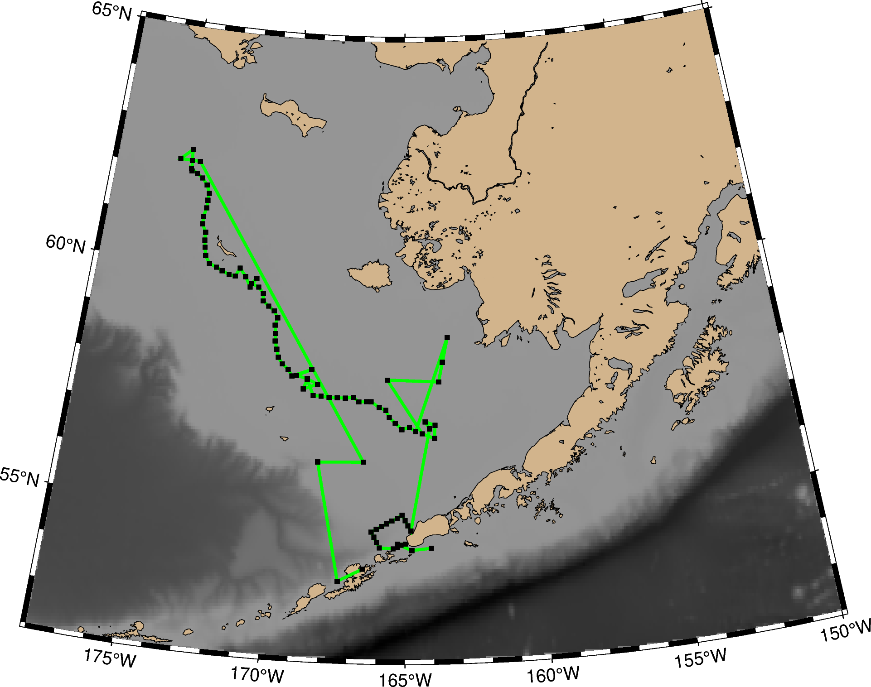

**Appendix 2. Map with directions to emergency department in Dutch Harbor, AK and Kodiak, AK**

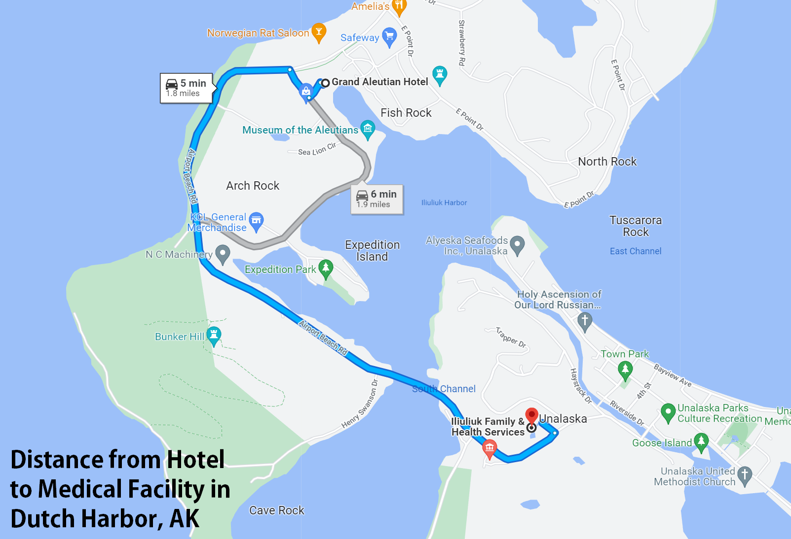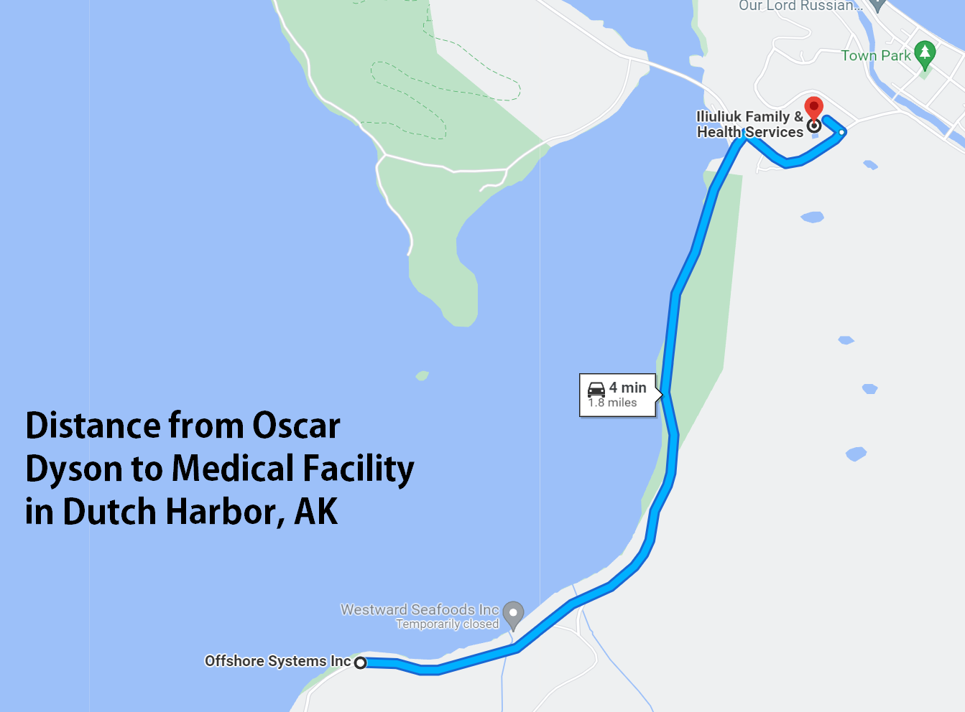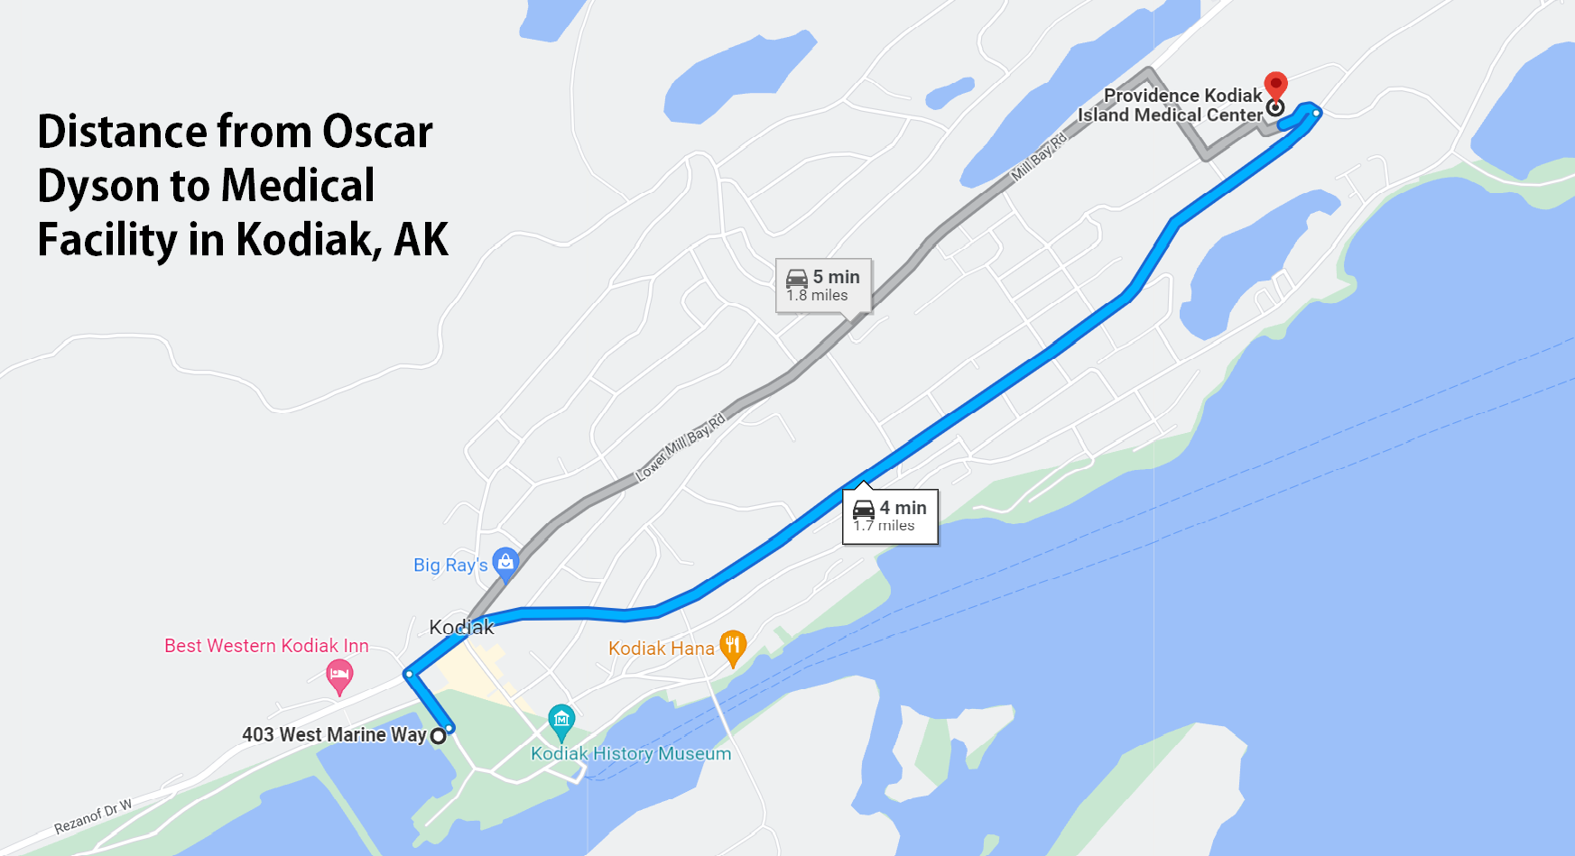

**Appendix 3. Participant Packing List including Supplemental COVID-19 Supplies**

**Personal Gear**

Mustang float coat

# Waterproof rain bib pant

Warm work gloves

Warm layers

Steel-toed boots

**COVID-19 Supplementary Gear**

Face Masks – Cloth or disposable (1/day for cloth or 5/day for disposable)

Gloves (5 pairs/ day)

Goggles/Eye Protection (1 pair/ person)

Disinfecting wipes

Hand sanitizer (1 small bottle/ person + extra)

**Appendix 4. First Aid Training Certification**



